Report DA559A – Lab 1
Mikael Holst Mattsson
mikael.holst_mattsson0078@stud.hkr.se

Description of project
The project is a start for a wine inventory program which I want to use in my wine import business. The database consists of two tables “wines” and “producers” and the SQL-script for the creation of the tables and data can be found in “db/create.sql”. The script “db/create_schema.js” is a script which executes this SQL-statement.
“npm start” launches “app.js” which contains the Node-server to handle the API-call. See “JSON response from server” on page 3.
/json/wines - To see all wines in the database, use endpoint
/json/wine/[id] – see the details of one specific wine bottle
I have integrated the CLI-interface in the app.js so when running “npm start” you have the option to launch the CLI tool. Here you can view all wines and also all producers. With this tool you can also add a wine to the database.

What went well?
The lectures in total gave a good insight into the usage of NodeJS and Express. I have some experience with Python and React development as well as working with databases so a lot of the concepts were not new but working more in-depth with JavaScript and NodeJS was interesting.
Easy setting up the coding environment and installing the packages went smoothly. Hade some difficulties with connecting to the database, but this was due to that I did not supply a “PORT”-number with the connecting string.
Very appreciated to be able to alter the Lab so that I could make a custom database for my wine import business. Always funnier to code something that you are involved with.

What could you have done differently?
I started off ahead of the lectures which lead to using “require” instead of “import” which lead to error further on when this was introduced. This was the downpart of running a head.
Tried to build cli on top of the webserver was a challenge, but this was due to me running ahead and not wanted to delete anything for the upcoming Lab 2. I have still not managed to get rid of the “echo” from the readline-interface in the CLI-menu-function.
The whole project can be more refractured into smaller and more logical modules. Cleaner code is always better, but I hope that I’ve shown the knowledge to be able to pass Lab1.

Screenshots of your database schema
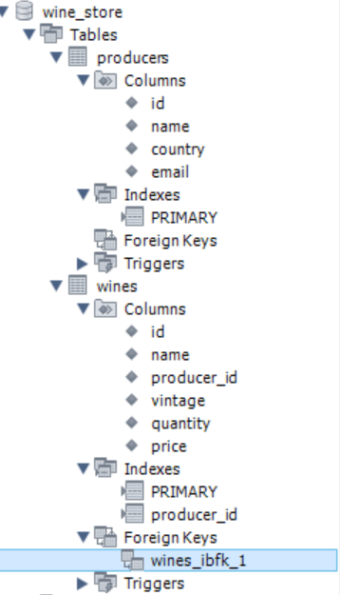
In the repository the full SQL command to create the tables and data can be found in “./db/create.sql”.

JSON response from server
